Detection and Prevention of DoS Attacks Using Machine Learning Techniques
Final Report
ICT607 – Artificial Intelligence for Cyber Security
Group 16
- Jyothi Ravipati – 34784275
- E.H. Dinuka Sandaruwan – 35048058
- Van Sanh VU – 34900798
- Muhammad Danyal Khan – 34721903

Executive Summary
This project explores machine learning (ML) techniques to detect and prevent Denial-of-Service (DoS) attacks. Using the UNSW-NB15 dataset, we built and evaluated models to distinguish malicious traffic from legitimate traffic. We tested two models—Random Forest and Support Vector Machine (SVM)—and found that Random Forest outperformed SVM with higher accuracy and robustness. Our results suggest that ML-based systems can effectively enhance intrusion detection and network defence mechanisms against evolving DoS threats.
Dataset Selection and Pre-Processing
We used the UNSW-NB15 dataset, developed by the Australian Centre for Cyber Security, containing over 2.5 million rows and 49 features with diverse regular and attack traffic.
Data preprocessing and feature selection.
When you download the dataset in Google Colab, it will come as a few separate files like the attached image below.
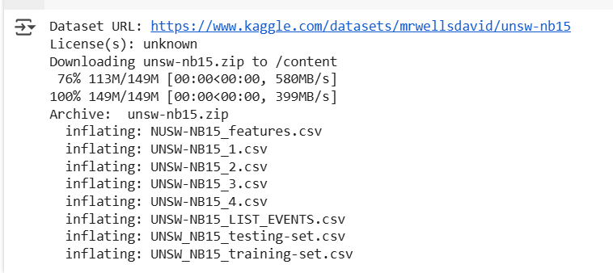
We even used processed training and testing datasets for ML model training at the project proposal level. In this stage, we will use row data files to improve the training dataset. Therefore, we combine 4 row data files and a feature file to make the training dataset.
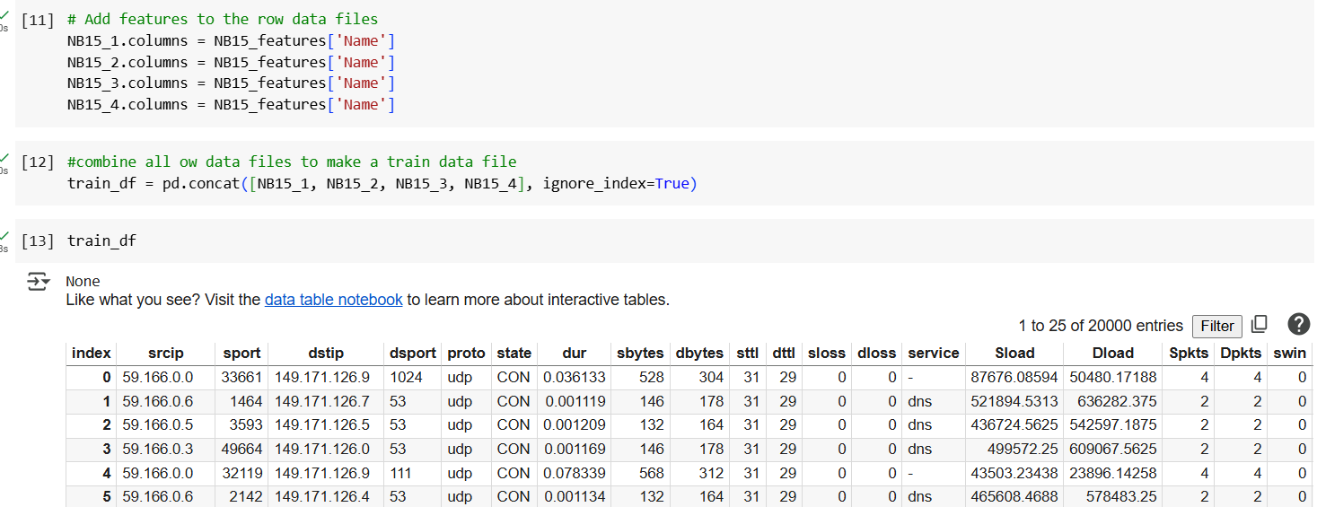
Fig. 1.1 combines all row files with the feature file and builds a new training dataset.

All the features in the dataset
No. | Name | Type | Description
1 | srcip | nominal | Source IP address
2 | sport | integer | Source port number
3 | dstip | nominal | Destination IP address
4 | dsport | integer | Destination port number
5 | proto | nominal | Transaction protocol
6 | state | nominal | TCP state (e.g., CON, FIN, REQ)
7 | dur | float | Record total duration
8 | sbytes | integer | Bytes from source to destination
9 | dbytes | integer | Bytes from destination to source
10 | sttl | integer | Source TTL value
11 | dttl | integer | Destination TTL value
12 | sloss | integer | Source packets retransmitted or dropped
13 | dloss | integer | Destination packets retransmitted or dropped
14 | service | nominal | Application service type (http, ftp, etc.)
15 | Sload | float | Source bits per second
16 | Dload | float | Destination bits per second
17 | Spkts | integer | Packet count from source to destination
18 | Dpkts | integer | Packet count from destination to source
19 | swin | integer | Source TCP window size
20 | dwin | integer | Destination TCP window size
21 | stcpb | integer | Source TCP base sequence number
22 | dtcpb | integer | Destination TCP base sequence number
23 | smeansz | integer | Mean packet size from source
24 | dmeansz | integer | Mean packet size from destination
25 | trans_depth | integer | HTTP transaction depth (pipeline depth)
26 | res_bdy_len | integer | Response body length (uncompressed)
27 | Sjit | float | Source jitter (ms)
28 | Djit | float | Destination jitter (ms)
29 | Stime | timestamp | Record start time
30 | Ltime | timestamp | Record end time
31 | Sintpkt | float | Source interpacket arrival time (ms)
32 | Dintpkt | float | Destination interpacket arrival time (ms)
33 | tcprtt | float | TCP connection round-trip time
34 | synack | float | SYN to SYN-ACK time
35 | ackdat | float | SYN-ACK to ACK time
36 | is_sm_ips_ports | binary | 1 if src and dst IPs and ports match, else 0
37 | ct_state_ttl | integer | Count of states with TTL match
38 | ct_flw_http_mthd | integer | Count of flows with HTTP GET/POST methods
39 | is_ftp_login | binary | 1 if FTP session was logged in, else 0
40 | ct_ftp_cmd | integer | Number of FTP commands in the session
41 | ct_srv_src | integer | Connections with same service and source IP
42 | ct_srv_dst | integer | Connections with same service and destination IP
43 | ct_dst_ltm | integer | Connections to same destination in last 100
44 | ct_src_ ltm | integer | Connections from same source in last 100
45 | ct_src_dport_ltm | integer | Connections with same source IP and destination port
46 | ct_dst_sport_ltm | integer | Connections with same destination IP and source port
47 | ct_dst_src_ltm | integer | Connections between same src and dst IPs
48 | attack_cat | nominal | Attack category (e.g., DoS, Exploits, Recon)
49 | Label | binary | 1 for attack, 0 for normal

Feature selection
Importance of feature selection
This project aims to detect denial-of-service (DoS) attacks, which are not every type of cyber threat. Therefore, using only the most relevant features offers several advantages:
- Improve Model Interpretability
The fewer and more meaningful the features, the easier it is to understand what your model is doing and why it makes specific predictions. If the model is trained on 10–20 DoS-specific features (e.g., dur, sbytes, Spkts, state, tcprtt), we can analyse which influences the model most.
For example, short durations and high packet counts are strong indicators of a DoS attack, which aligns with known behaviour.
- Reduce Noise
Irrelevant features can confuse the model, leading to overfitting or poor generalisation. Including irrelevant data (like srcip, Stime, or sport) may introduce random patterns that don’t generalise to real-world attacks.
For DoS, fields like is_ftp_login or ct_ftp_cmd may have limited relevance and can distract the model if included unnecessarily. Removing these helps the model focus on the actual attack indicators, reducing false positives and improving accuracy.
- Possibly Improve Performance and Training Time
Fewer features make fewer computations, which helps speed up training and predictions.
With 49 features, training an ML model involves computing decision boundaries across all dimensions, which increases time and memory usage. Reducing to 20–30 critical DoS features can reduce this significantly, especially for algorithms like Random Forests, SVM, or Neural Networks. Faster training times (useful when tuning hyperparameters or running cross-validation). Faster inference times (necessary for real-time detection systems)
Selecting features
The selected features from the UNSW-NB15 dataset were chosen based on their relevance to the behaviours exhibited across multiple types of Denial-of-Service (DoS) attacks. These features enable the model to identify anomalies related to the categories below effectively.
🔷 1. Key Network Traffic Features
Feature | Justification
dur | DoS sessions are typically short-lived, as attackers quickly overwhelm the system.
sbytes, dbytes | DoS traffic involves abnormal traffic volume, often either large bursts or extremely low payloads in high numbers.
Spkts, Dpkts | Measures packet rate; DoS generates a high number of packets in short time spans.
Sload, Dload | Captures data transfer rate; high Sload/Dload rates may indicate flooding behavior.

🔷 2. Transport Layer / Protocol Behaviour Features
Feature | Justification
sttl, dttl | TTL values help detect spoofed or unusual routing behavior common in reflection/amplification attacks.
tcprtt | High or low TCP round-trip times may indicate latency under flood conditions.
synack | Abnormal SYN-ACK times reflect incomplete handshakes, especially in SYN flood attacks.
ackdat | May reveal anomalies in TCP connection completion patterns.
is_sm_ips_ports | Identifies if source IP and destination IP/ports match — attackers may mimic legitimate behavior.
sloss, dloss | DoS causes packet drops or retransmissions due to buffer overflow or congestion.
dsport | Certain ports (80, 443, 53, etc.) are commonly targeted in DoS attacks.
proto | Protocol type (TCP, UDP, etc.) — many DoS attacks abuse UDP due to lack of handshake.
state | TCP state transitions can signal abnormal session patterns like repeated INT, RST, or CON.

🔷 3. Connection-Based Features
Feature | Justification
ct_srv_dst | Number of connections to the same service and destination — typical of volumetric attacks.
ct_dst_ltm | Tracks number of connections to same destination IP recently — high values may indicate a targeted flood.
ct_src_dport_ltm | Same source attacking the same destination port — common in port-specific DoS campaigns.
ct_dst_sport_ltm | Repeated connections from same source port — may reflect a single bot or script.
ct_dst_src_ltm | Total flows between the same source and destination — high frequency is a strong DoS indicator.

🔷 4. Application-Layer & Session Features
Feature | Justification
service | Attacks often target specific application-layer services like HTTP, DNS, FTP.
ct_flw_http_mthd | DoS attacks (esp. Layer 7) flood servers with GET/POST requests.
is_ftp_login | Detects abuse of FTP login attempts — e.g., slow FTP or brute force flooding.
ct_ftp_cmd | Flooding FTP servers with commands can consume server resources.
res_bdy_len | HTTP flood or slow POST attacks may involve unusual response body sizes.
trans_depth | Application-level DoS may involve deeply nested or complex HTTP pipelines.

🔷 5. Behavioural / Statistical Features
Feature | Justification
smeansz, dmeansz | Mean packet sizes — abnormal distribution may reveal protocol misuse.
Sjit, Djit | Jitter spikes under stress — DoS affects packet timing stability.
Sintpkt, Dintpkt | Inter-packet timing becomes irregular in both volumetric and slow-rate attacks.

🔷 6. Attack-Specific
Feature | Justification
attack_cat | Useful for post-model evaluation — helps filter out DoS-specific instances during training/validation.
Label | Main target variable — 1 for attack, 0 for normal.

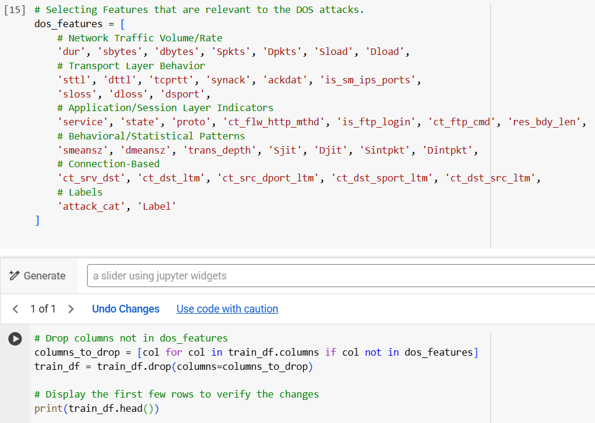
Figure 1.2: Feature selection and drop other features
Handling Null values
Handling missing values is very important when building a model to detect DoS attacks. If we don’t fix these missing values, the model might not work properly or could give wrong results. Instead of removing useful data, we can fill in missing values in a smart way.
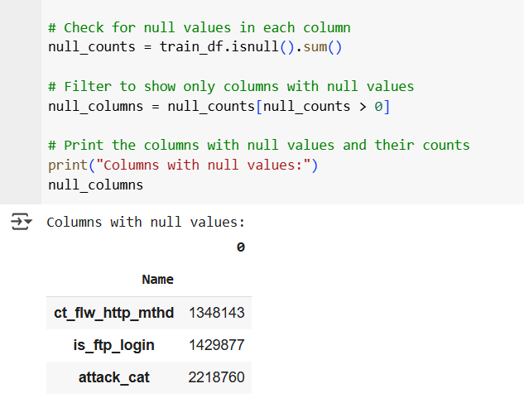
Fig. 1 .3 Identifying missing values.
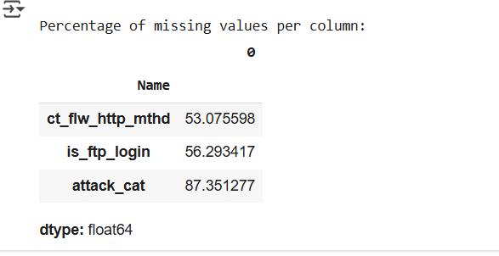
Figure 1.4: Checking percentages of missing values.
The following steps were taken to clean and prepare important features for DoS detection. Missing values in attack_cat were replaced with 'normal' to clearly mark non-attack traffic. For ct_flw_http_mthd and is_ftp_login, missing values were filled with 0 to indicate the absence of HTTP methods or FTP logins. These replacements not only preserve useful data but also help the model understand normal behaviour more accurately, leading to better and more reliable attack detection.
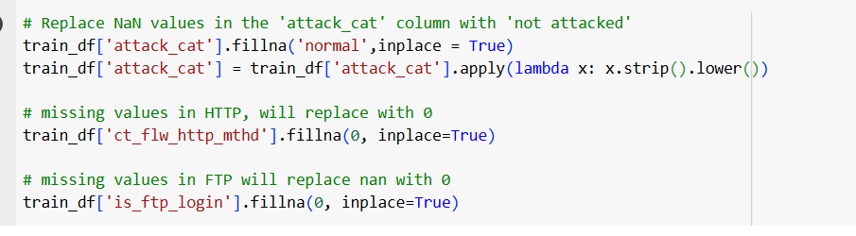
Figure 1.4: Handling missing values.
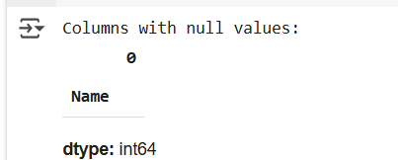
Figure 1.5: get confirmation of 0 null values
Handling Duplicate Values
Duplicate rows can bias your model, especially in DoS detection, where repeated traffic patterns might look normal due to over-representation.
Removing them:
- Reduces redundancy in the data
- Improves training efficiency
- Prevents overfitting to repeated patterns
- Leads to more accurate generalisation on unseen data

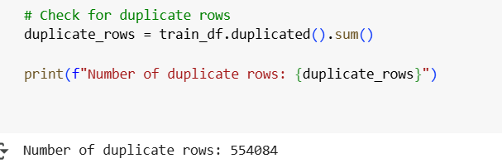
Therefore, we need to remove duplicate data.
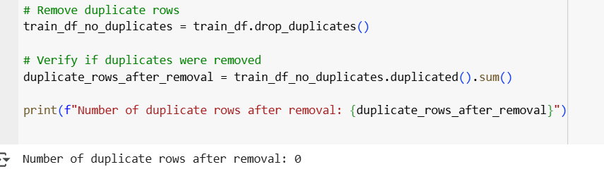
Figure 1.6: Removing duplicate rows in the data set.
Feature Engineering
Separating numerical and categorical features is important because they need to be prepared in different ways before training a machine learning model. Numbers are usually scaled to keep values in the same range, while text or category data needs to be changed into numbers using encoding. This is needed because most machine learning models only work with numbers. Keeping them separate also helps us better understand which features are helping the model find DoS attacks.
Checking categorical and numerical data types.
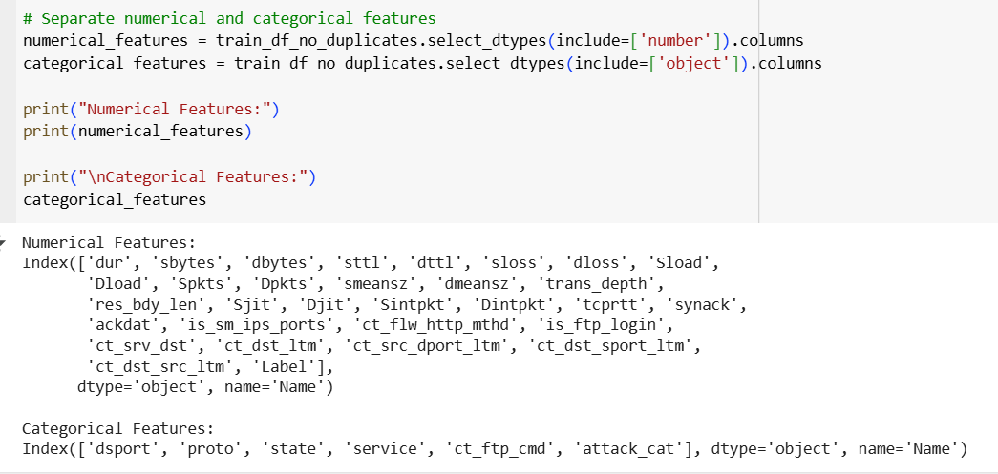
Figure 1.7: Output of the categorical and numerical data types.
Numerical features can be directly used in machine learning models and capture the scale, frequency, and intensity of network traffic. But these represent categorical data that need to be encoded before model training.
Checking Unique Values of the Categorical Features.
Before training a machine learning model, we need to convert text categories into numbers so the model can understand them. Knowing the unique values helps us:
- Understand the range of categories
- Catch inconsistent values (like '0' and 0 as separate entries)
- Decide whether to use Label Encoding or One-Hot Encoding
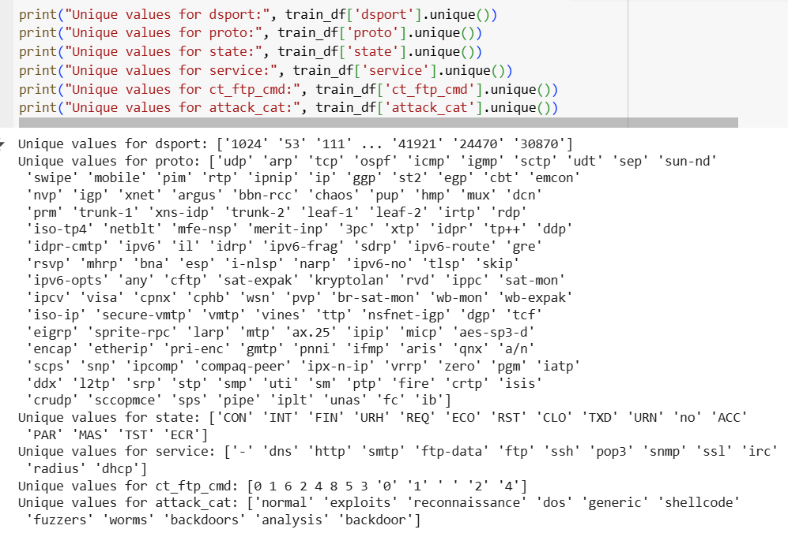
Figure 1.8 Unique values output of the categorical features.
Action taken:
- dsport (Destination Port) - Appears as a string, even though it's numeric. Therefore, we can convert it to an integer.
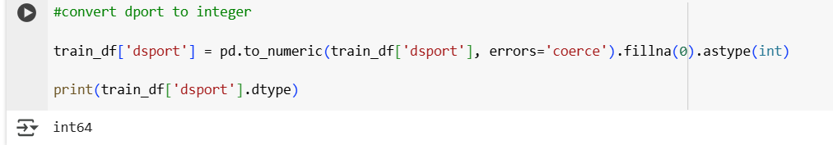
Figure 1.9: converting “dport” to an integer.
- ct_ftp_cmd - Contains mixed types, numbers and strings like '0', '1', ' ' (a blank string). Therefore, we need to clean and convert it to an integer.
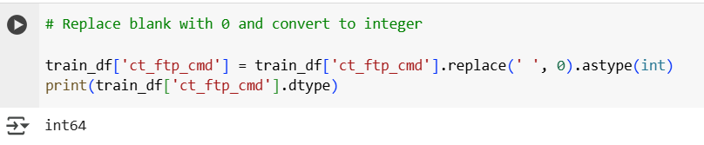
Figure 1.10: converting “ct_ftp_cmd ” to an integer
- proto, state, service, attack_cat – since our categorical features have many unique values (e.g., proto, dsport), we must use label encoding. Label Encoding is memory-efficient and keeps the dataset compact by using a single column instead of many.
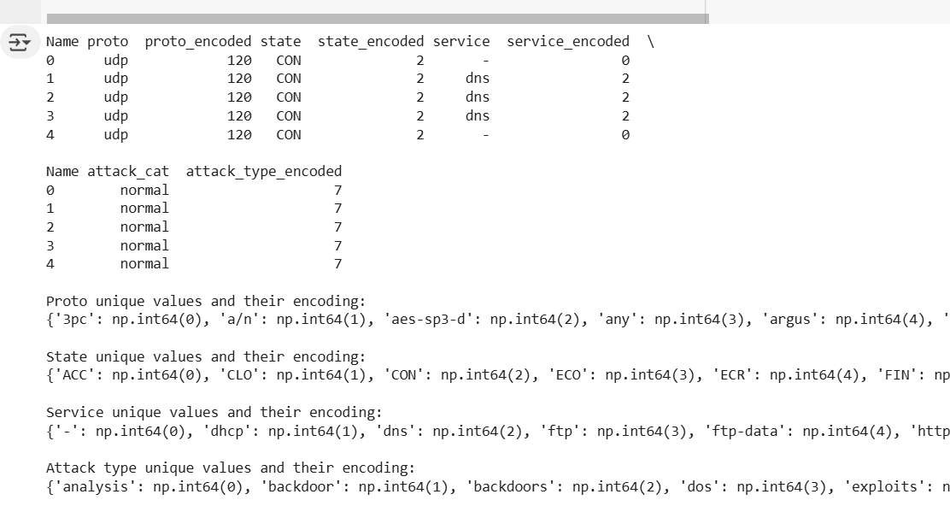
Figure 1.11: Label encoding result.

EDA
1.Attack type distribution without Normal data
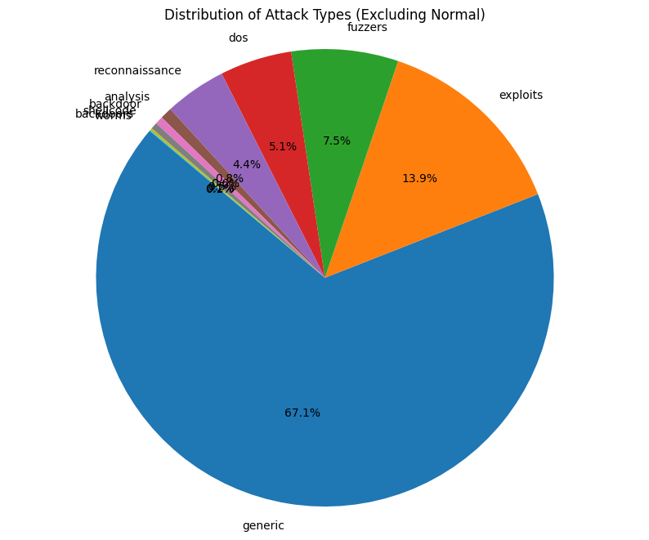
The pie chart shows the distribution of different cyberattack types, excluding normal traffic, with generic attacks making up the largest portion at 67.1%. This indicates that broad or automated threats are the most common in the dataset. Exploits follow at 13.9%, targeting software vulnerabilities, while fuzzers account for 7.5%, often used to discover such vulnerabilities. DoS (Denial of Service) attacks represent 5.1%, highlighting their relevance in the threat landscape. Reconnaissance activities make up 4.4%, suggesting a notable level of scanning and probing. The remaining categories, including analysis, backdoor, shellcode, worms, and backdoors, each contribute less than 1%, indicating they are less frequent but may still pose significant risks.
2. Correlation Heatmap
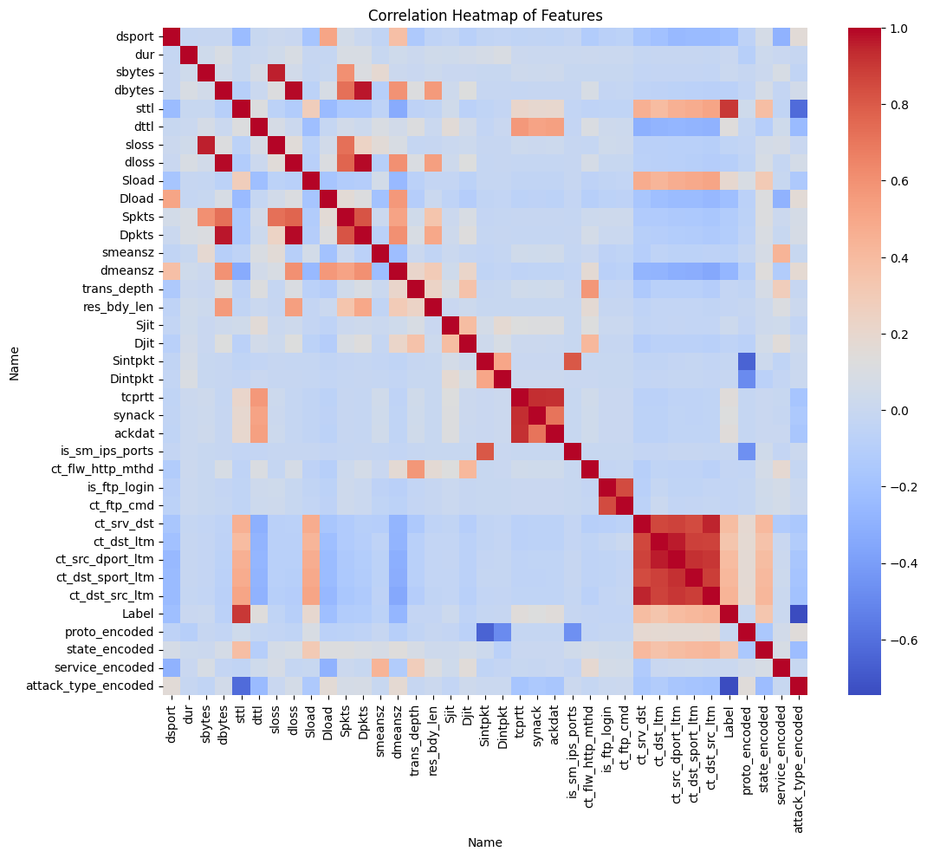

The correlation heatmap visualises the relationships between features in the dataset, with values ranging from -1 to 1. Features like sbytes, dbytes, and sttl show strong positive correlations with each other, indicating they tend to increase or decrease together, which could be due to shared characteristics in traffic patterns. There is a notable cluster of strong correlations involving encoded categorical features such as proto_encoded, state_encoded, and service_encoded, as well as with attack_type_encoded, suggesting these variables carry predictive patterns relevant to attack classification. Some negative correlations, shown in blue, indicate inverse relationships, such as between Label or attack_type_encoded and various numeric features, which can be useful for distinguishing normal from malicious activity.
Handling class in balance
Balancing all attack types to 15,000 samples ensures the model gives equal attention to each class, which helps address class imbalance, a common issue in cybersecurity datasets like UNSW-NB15. Without balancing, the model tends to focus on frequent classes like "Normal" or "Generic," while ignoring rare but critical ones like "DoS" or "Worms." By equalising class sizes, the model learns to detect all attacks more accurately, improves recall and F1-score for minority classes, and leads to more fair and reliable evaluation across all types of intrusions.
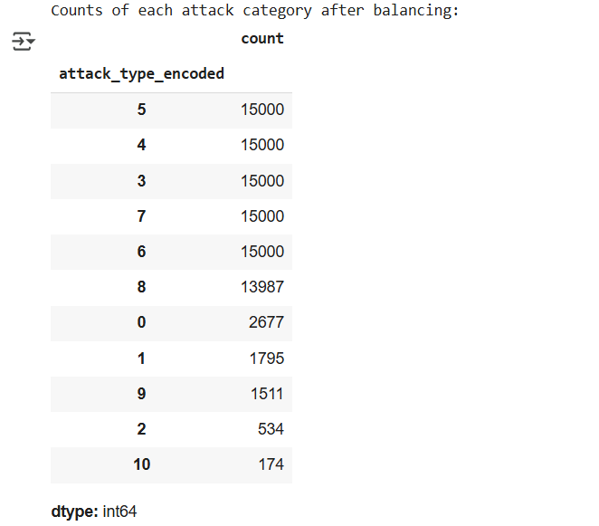

- Attack type distribution after addressing class imbalance.
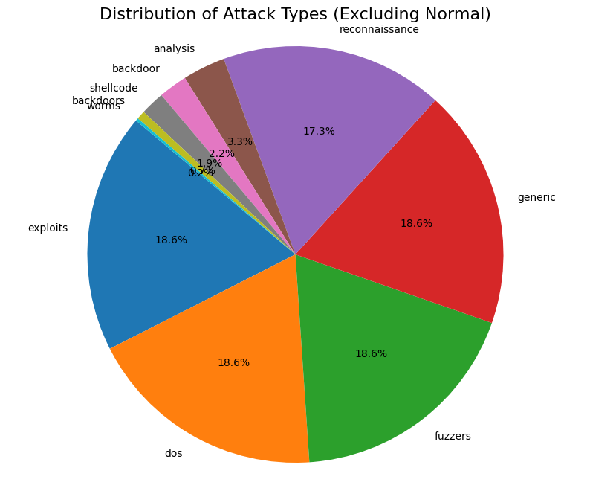

ML Model
Randon forest
We used Random Forest for this project because it is a powerful and reliable machine learning algorithm that works well on complex, high-dimensional datasets like UNSW-NB15, which contains many network traffic features. Random Forest is an ensemble method that builds multiple decision trees and combines their outputs, making it robust to overfitting, especially when the data has a mix of numerical and categorical variables. It can handle imbalanced classes, is relatively fast to train, and provides good accuracy and recall without heavy parameter tuning. Most importantly, it offers feature importance insights, helping us understand which traffic attributes are most useful for detecting DoS and other attacks.
- Handles High-Dimensional Data Well: Suitable for datasets like UNSW-NB15 with many features.
- Robust to Overfitting: Combines multiple decision trees to improve generalization.
- Supports Mixed Data Types: Works well with both numerical and categorical features (after encoding).
- Performs Well on Imbalanced Data: Can be combined with techniques like SMOTE and still perform reliably.
- High Accuracy and Recall: Delivers strong results for detecting DoS attacks and other intrusion types.
- Low Parameter Tuning Needed: Easy to use and effective without deep hyperparameter optimization.
- Provides Feature Importance: Helps identify which features contribute most to the model’s predictions.
- Fast Training: Efficient and scalable for large datasets.

Result
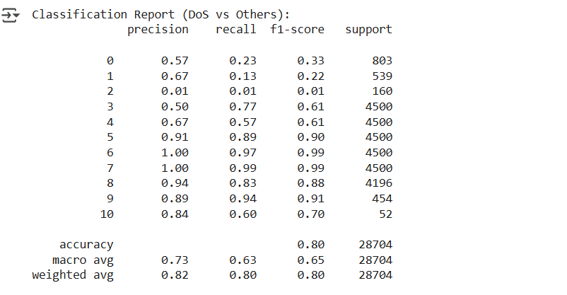

- DoS Detection (Class 3):
- Precision: 0.50 – Half of the predicted DoS attacks were correct.
- Recall: 0.77 – The model correctly identified 77% of actual DoS attacks.
- F1-score: 0.61 – A good balance between precision and recall.
- This shows strong detection capability for DoS attacks.
- Well-Detected Classes:
- Classes 5 (F1 = 0.90), 6 and 7 (F1 = 0.99), 9 (F1 = 0.91), and 8 (F1 = 0.88) are performing excellently.
- Poorly Detected Classes:
- Classes 0, 1, and especially 2 show low recall and F1, meaning the model struggles to detect them.
- Overall Accuracy: 80%
- This is strong for a multi-class security classification task.
- Macro Avg F1 (0.65):
- Reflects the average performance across all classes, showing moderate balance.
- Weighted Avg F1 (0.80):
- Indicates that the model performs well overall, especially on frequent classes.
Confusion Metrix
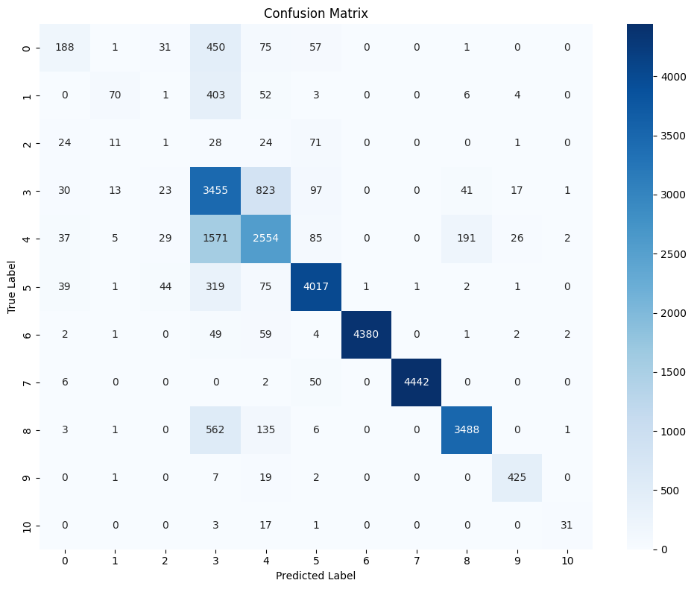
- Class 3 (DoS):
    - Correctly predicted 3,455 times.
    - Commonly confused with class 4 (823 times), indicating DoS and class 4 share similar patterns.
- Class 6 and 7 (e.g., benign/normal):
    - Very strong performance with 4,380 and 4,442 correct predictions, respectively.
    - Almost no confusion with other classes.
- Class 5:
    - Predicted very accurately (4,017 correct), but confused sometimes with classes 3 and 4.
- Class 2 (e.g., rare attack):
    - Poor performance, only 1 correct prediction, many misclassifications.
Support Vector Machine
We use Support Vector Machine (SVMs) here because it is effective in High-Dimensional Spaces. SVMs are known to be effective in high-dimensional spaces, which is often the case with network traffic data that can have many features like UNSW-NB15. Moreover, SVMs can use ‘rbf’ kernel functions to handle non-linear relationships between features, allowing them to capture complex patterns in the data. It can map data into an infinite-dimensional space, allowing it to capture complex non-linear relationships very effectively. It's quite flexible and can perform well on a wide variety of datasets. However, SVMs consume time for training and prediction compared to the Random Forest model.
Result
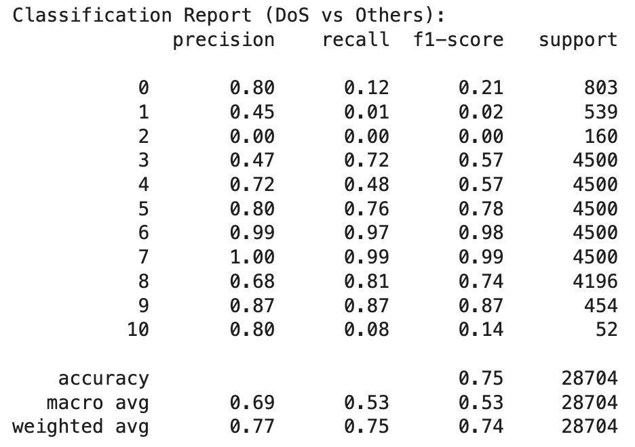
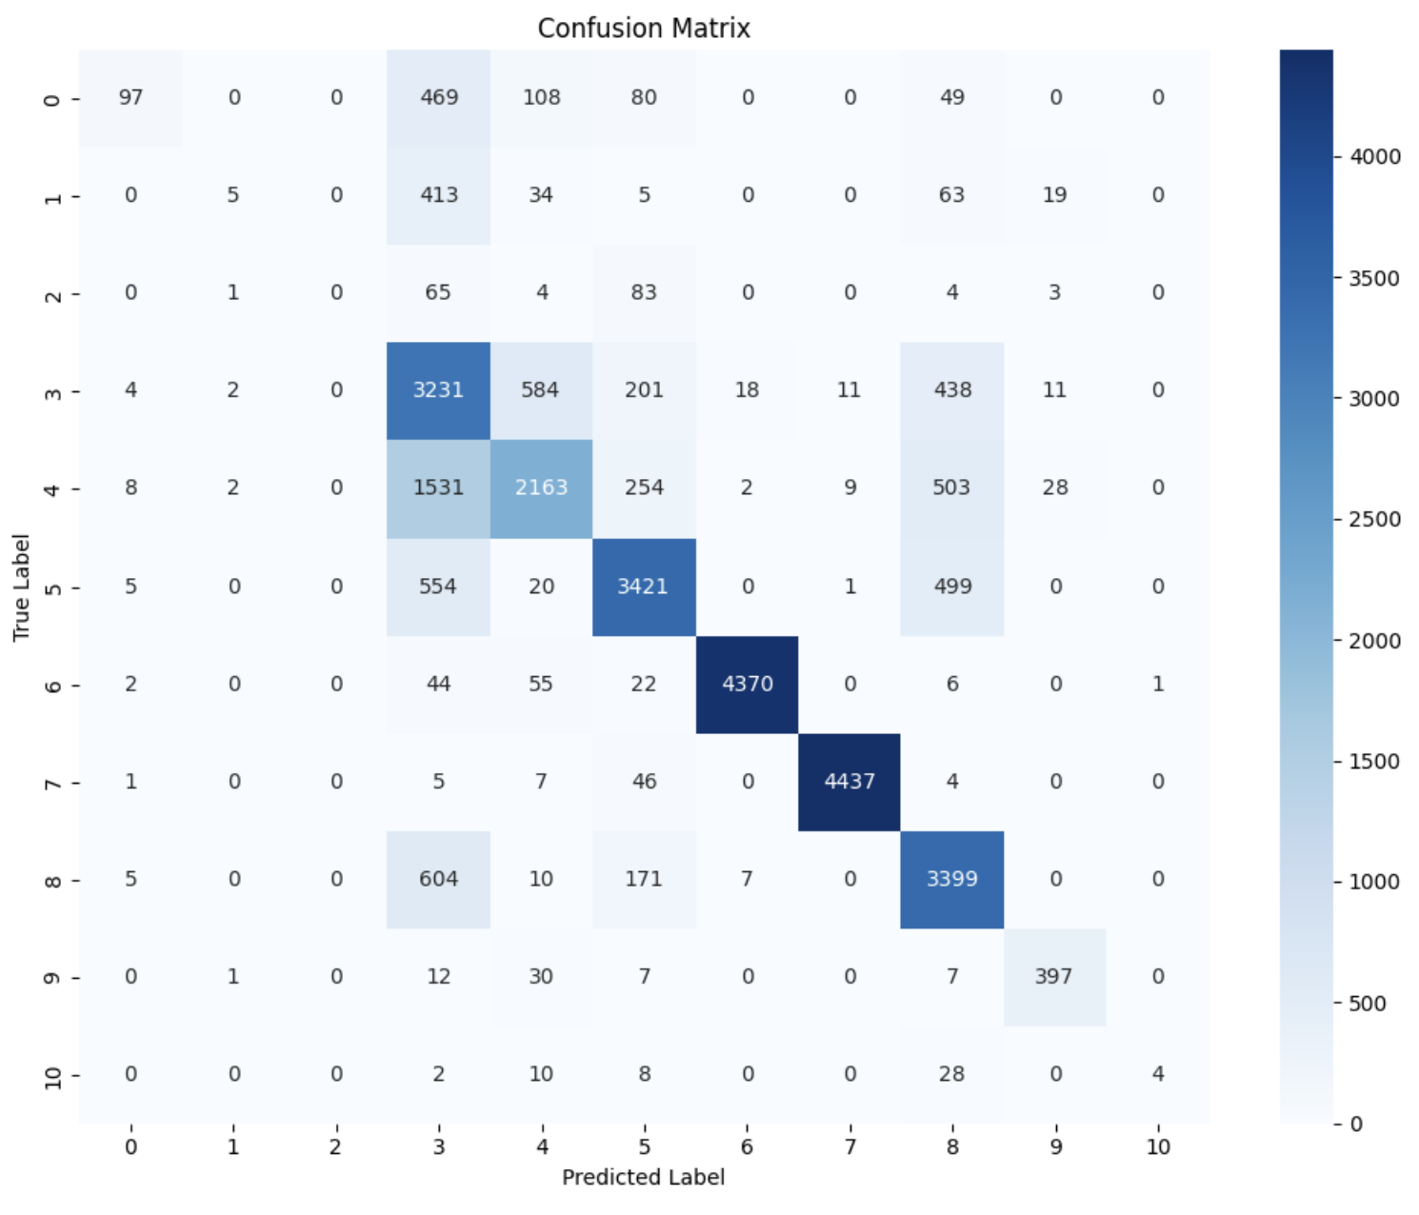

Comparative Analysis
Evaluation Metrics:
- Accuracy: Represents the ratio of correctly predicted instances to the total number of instances.
- Precision: Reflects the proportion of true positives among all predicted positive cases.
- Recall: Indicates the proportion of true positives identified among all actual positive instances.
- F1-Score: The harmonic mean of precision and recall, offering a balanced measure of both.
Algorithm Effectiveness Discussion:
- Random Forest: Achieved moderate performance with an accuracy for DoS (class 3) score of around 0.5. While it was reasonably effective in identifying anomalies for other classes, such as 5, 6 and 7.
- Support Vector Machine (SVMs): Performed well, with an accuracy score nearing 0.47 for class 3 (DoS). Although its classification accuracy was not perfect.
The results show that although both models have their advantages, the Random Forest consistently outperformed the SVMs across all evaluation metrics, including accuracy, precision, recall, F1-score, and ROC-AUC. Its strength in capturing complex patterns within high-dimensional data makes it a more effective option for improving Intrusion Detection Systems (IDS) and identifying network anomalies.
Performance comparison charts
These charts compare the performance metrics of the two algorithms, providing a clear visual representation of their effectiveness. Analysing these charts helps us gain insights into the strengths and weaknesses of each model across various evaluation metrics.
Accuracy visualisation:
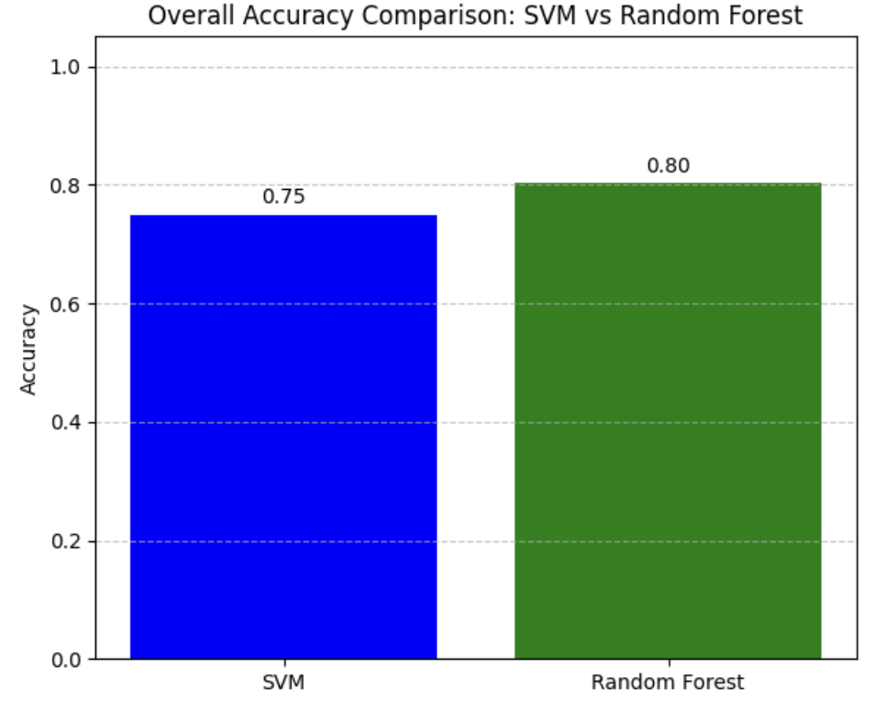
Precision, Recall, F1-score between classes:
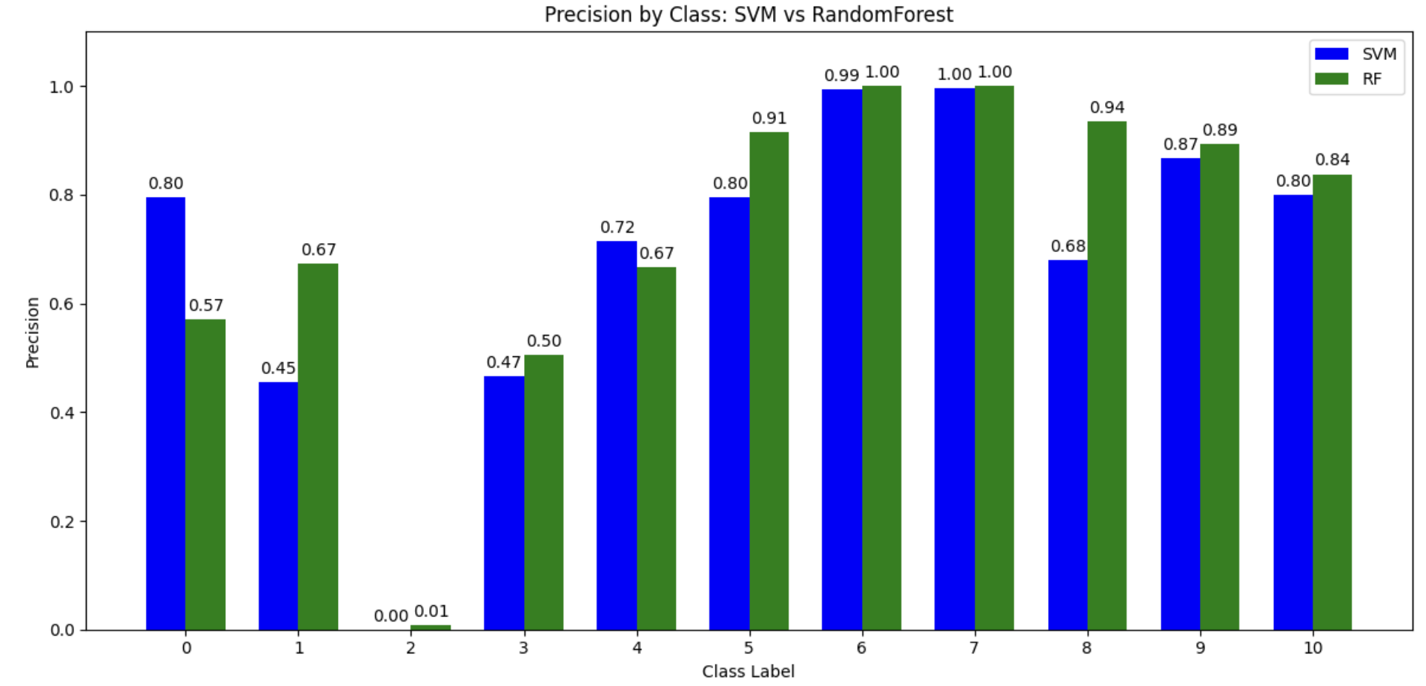
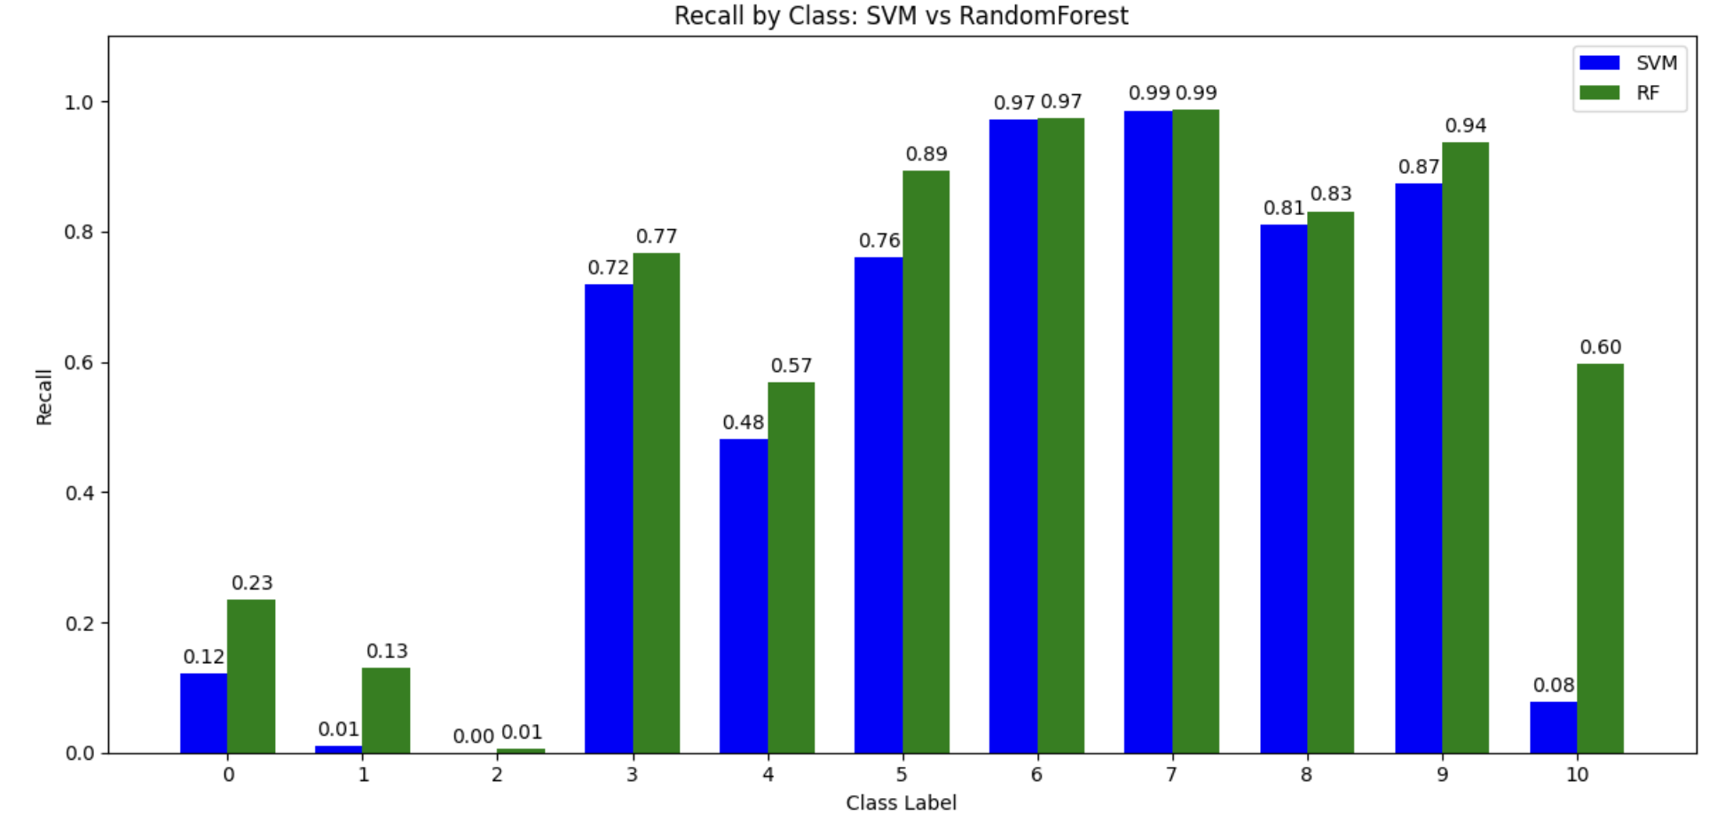
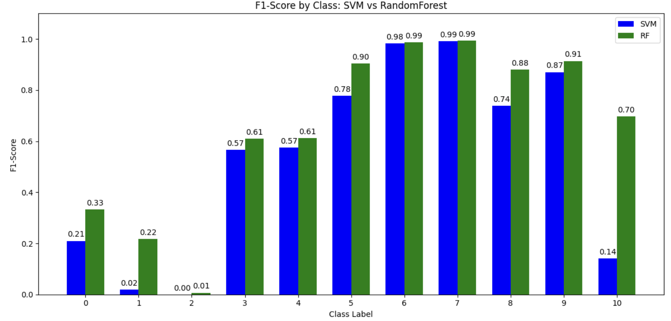
Conclusion
Based on our comparative study, we have drawn several critical conclusions regarding the performance and suitability of each algorithm for the detection and prevention of DoS attacks with the UNSW-NB15 dataset.
In the classification task of DoS vs other attack types, both SVM and Random Forest show effectiveness, but their strengths differ:

SVM (Support Vector Machine)
- Performs reasonably well on the majority of classes, particularly when the data is well-separated.
- However, it struggles with imbalanced datasets, showing low recall and F1-scores for minority classes.
- Overall accuracy: 75%

Random Forest
- Achieves higher accuracy (80%) and significantly better recall/F1-scores across all classes, especially minority ones.
- Handles imbalanced and complex datasets more effectively due to ensemble learning.
- More robust, stable, and interpretable, with feature importance insights.
- Best suited for: larger, imbalanced, and noisy datasets requiring strong generalisation.
Code Explanation
This project encompasses the full machine learning workflow: from dataset loading and preprocessing to model training, performance evaluation, and result visualisation. The codebase is systematically structured to reflect each stage of this process clearly

Code Structure and Organisation
The implementation is divided into well-defined sections, each responsible for a specific task:
- Data Loading and Preprocessing
Handles importing the dataset, managing missing values, encoding, balancing, feature scaling, and splitting the data into training and test sets.
- Model Implementation
Includes the development and training of machine learning models, Random Forest and Support Vector
- Model Evaluation
Assess the performance of each model using tools like classification reports and confusion matrices.
- Visualization
Produces comprehensive visualisations to support model analysis, confusion matrices, and bar charts

Access dataset

Log in to the Kaggle website and create a token to connect to Kaggle’s API

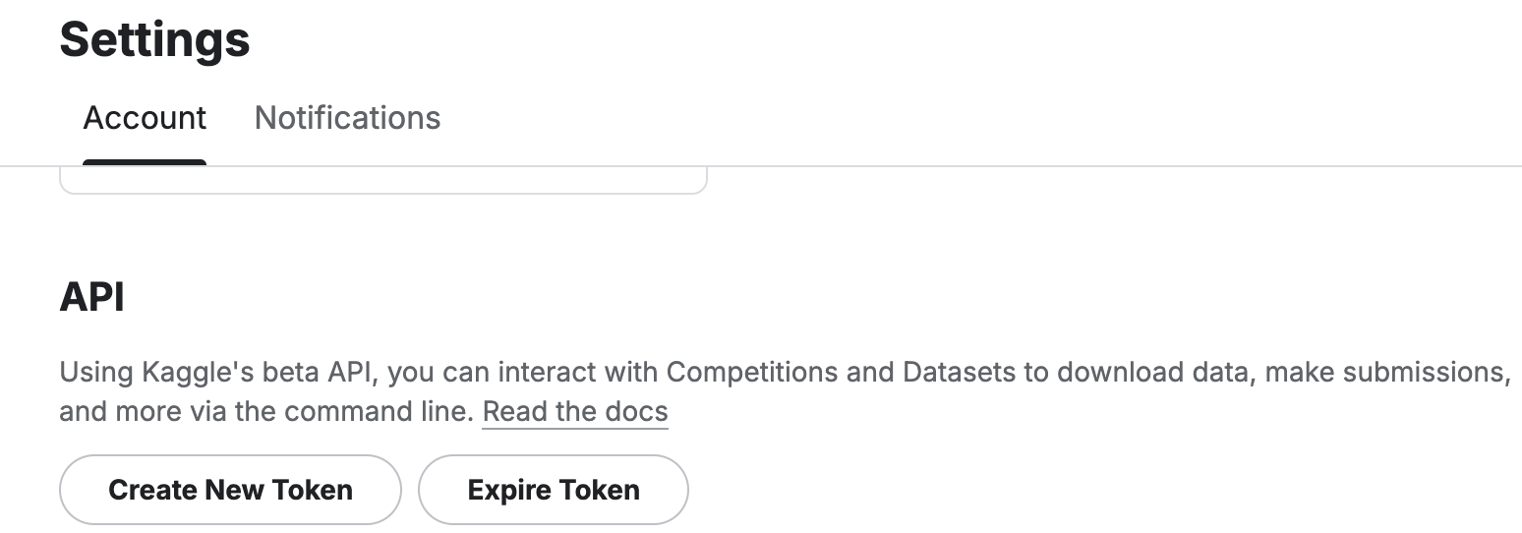

Required Libraries:
- Pandas
- Scikit-learn
- Matplotlib
- Seaborn
- Numpy

Setting up the Environment and Downloading Data
This first section of the code focuses on setting up the environment for data access, specifically for downloading a dataset from Kaggle.
pip install kaggle

from google.colab import drive
drive.mount('/content/drive')
import os
!mkdir -p ~/.kaggle
!cp /content/drive/MyDrive/kaggle/kaggle.json ~/.kaggle/
!chmod 600 ~/.kaggle/kaggle.json
This code sets up your Kaggle credentials in the Colab environment: interacting with the operating system, creating a directory, copying the token kaggle.json to the directory and setting permission read & write
!kaggle datasets download -d mrwellsdavid/unsw-nb15
!unzip unsw-nb15.zip
Download the dataset specified and then extract the dataset files into the current directory.

Loading and Initial Data Inspection
Loading the pandas library to load the downloaded CSV files into DataFrames and perform initial inspections.
import pandas as pd
# Try reading with ISO-8859-1 encoding
NB15_features = pd.read_csv("NUSW-NB15_features.csv", encoding="ISO-8859-1")
print(NB15_features.to_string()) # Show all rows and columns
NB15_1 = pd.read_csv("UNSW-NB15_1.csv", encoding="ISO-8859-1")
print(NB15_1.head()) # Show all rows and columns
NB15_2 = pd.read_csv("UNSW-NB15_2.csv", encoding="ISO-8859-1")
print(NB15_2.head()) # Show all rows and columns
# %%
NB15_3 = pd.read_csv("UNSW-NB15_3.csv", encoding="ISO-8859-1")
print(NB15_3.head()) # Show all rows and columns
# %%
NB15_4 = pd.read_csv("UNSW-NB15_4.csv", encoding="ISO-8859-1")
print(NB15_4.head()) # Show all rows and columns
Read the CSV file and add the data into the pandas dataframe

Data Preparation and Cleaning
# Add features to the row data files
NB15_1.columns = NB15_features['Name']
NB15_2.columns = NB15_features['Name']
NB15_3.columns = NB15_features['Name']
NB15_4.columns = NB15_features['Name']
The column names of the four data DataFrames (NB15_1 through NB15_4) are replaced with the 'Name' column from the NB15_features DataFrame, and the features file contains the actual names of the network traffic features.
#combine all data files to make a train data file
train_df = pd.concat([NB15_1, NB15_2, NB15_3, NB15_4], ignore_index=True)
concatenates the four data DataFrames into a single DataFrame named train_df.
# Selecting Features that are relevant to the DOS attacks.
dos_features = [
# Network Traffic Volume/Rate
'dur', 'sbytes', 'dbytes', 'Spkts', 'Dpkts', 'Sload', 'Dload',
# Transport Layer Behavior
'sttl', 'dttl', 'tcprtt', 'synack', 'ackdat', 'is_sm_ips_ports',
'sloss', 'dloss', 'dsport',
# Application/Session Layer Indicators
'service', 'state', 'proto', 'ct_flw_http_mthd', 'is_ftp_login', 'ct_ftp_cmd', 'res_bdy_len',
# Behavioural/Statistical Patterns
'smeansz', 'dmeansz', 'trans_depth', 'Sjit', 'Djit', 'Sintpkt', 'Dintpkt',
# Connection-Based
'ct_srv_dst', 'ct_dst_ltm', 'ct_src_dport_ltm', 'ct_dst_sport_ltm', 'ct_dst_src_ltm',
# Labels
'attack_cat', 'Label'
]
Selecting the columns that are considered relevant for analysing Denial of Service (DoS) attacks. This is a domain-specific selection of features.
# Drop columns not in dos_features
columns_to_drop = [col for col in train_df.columns if col not in dos_features]
train_df = train_df.drop(columns=columns_to_drop)
# Display the first few rows to verify the changes
print(train_df.head())
dropping the columns from train_df that are not in the dos_features list.
# Check for null values in each column
null_counts = train_df.isnull().sum()
# Filter to show only columns with null values
null_columns = null_counts[null_counts > 0]
# Print the columns with null values and their counts
print("Columns with null values:")
null_columns
displaying columns that have missing (null) values.
# Calculate the total number of rows
total_rows = len(train_df)
# Calculate the percentage of missing values for each column with missing values
missing_percentage = (null_columns / total_rows) * 100
# Print the percentage of missing values
print("\nPercentage of missing values per column:")
missing_percentage
This calculates and prints the percentage of missing values for the columns identified in the previous step.
# Replace NaN values in the 'attack_cat' column with 'not attacked'
train_df['attack_cat'].fillna('normal',inplace = True)
train_df['attack_cat'] = train_df['attack_cat'].apply(lambda x: x.strip().lower())
# missing values in HTTP, will replace with 0
train_df['ct_flw_http_mthd'].fillna(0, inplace=True)
# missing values in FTP will replace nan with 0
train_df['is_ftp_login'].fillna(0, inplace=True)
This code handles some of the missing values, such as filling any missing values (NaN) in the attack_cat column with the string 'normal', cleaning the values in the attack_cat column by removing leading/trailing whitespace (strip()) and converting them to lowercase (lower()), fills missing values in the ct_flw_http_mthd column with 0, fills missing values in the is_ftp_login column with 0.
# Check for null values in each column
null_counts = train_df.isnull().sum()
# Filter to show only columns with null values
null_columns = null_counts[null_counts > 0]
# Print the columns with null values and their counts
print("Columns with null values:")
null_columns
# Check for duplicate rows
duplicate_rows = train_df.duplicated().sum()
print(f"Number of duplicate rows: {duplicate_rows}")
# Remove duplicate rows
train_df_no_duplicates = train_df.drop_duplicates()
# Verify if duplicates were removed
duplicate_rows_after_removal = train_df_no_duplicates.duplicated().sum()
print(f"Number of duplicate rows after removal: {duplicate_rows_after_removal}")
removes the duplicate rows and then verifies the removal
# Separate numerical and categorical features
numerical_features = train_df_no_duplicates.select_dtypes(include=['number']).columns
categorical_features = train_df_no_duplicates.select_dtypes(include=['object']).columns
print("Numerical Features:")
print(numerical_features)
print("\nCategorical Features:")
categorical_features
This code separates the columns into numerical and categorical types based on their data types, selects columns with numerical data types (integers, floats), extract the column names of the selected numerical columns, selects columns with 'object' data types, which typically represent strings or mixed types (often used for categorical data).

Exploring Categorical Features
# prompt: print all the unique values of this categorical features dsport, proto, state, service, ct_ftp_cmd, attack_cat
print("Unique values for dsport:", train_df['dsport'].unique())
print("Unique values for proto:", train_df['proto'].unique())
print("Unique values for state:", train_df['state'].unique())
print("Unique values for service:", train_df['service'].unique())
print("Unique values for ct_ftp_cmd:", train_df['ct_ftp_cmd'].unique())
print("Unique values for attack_cat:", train_df['attack_cat'].unique())
#convert dport to integer
train_df['dsport'] = pd.to_numeric(train_df['dsport'], errors='coerce').fillna(0).astype(int)
print(train_df['dsport'].dtype)
This code converts the dsport column to an integer data type. If a value cannot be converted, it is replaced with NaN (Not a Number) due to errors='coerce'. Fills any NaN values (created by errors='coerce') with 0. Converts the resulting values to integers. Assigns the converted data back to the dsport column.
# Replace blank with 0 and convert to integer
train_df['ct_ftp_cmd'] = train_df['ct_ftp_cmd'].replace(' ', 0).astype(int)
print(train_df['ct_ftp_cmd'].dtype)
This code cleans and converts the ct_ftp_cmd column to an integer.
# prompt: count all the types available in the attack_cat separately
# Count the occurrences of each unique value in the 'attack_cat' column
attack_cat_counts = train_df['attack_cat'].value_counts()
# Print the counts
print("Counts of each attack category:")
attack_cat_counts
This code counts the number of occurrences of each unique value in the attack_cat column. This helps understand the distribution of different attack categories in the dataset.

Encoding Categorical Features and Balancing Data
This section focuses on converting categorical features into numerical representations that can be used by machine learning models and then balancing the dataset to address class imbalance.
from sklearn.preprocessing import LabelEncoder
# Initialize separate encoders for each column
proto_encoder = LabelEncoder()
state_encoder = LabelEncoder()
service_encoder = LabelEncoder()
attack_encoder = LabelEncoder()
# Apply label encoding
train_df['proto_encoded'] = proto_encoder.fit_transform(train_df['proto'])
train_df['state_encoded'] = state_encoder.fit_transform(train_df['state'])
train_df['service_encoded'] = service_encoder.fit_transform(train_df['service'])
train_df['attack_type_encoded'] = attack_encoder.fit_transform(train_df['attack_cat'])
# Display sample of encoded results
print(train_df[['proto', 'proto_encoded', 'state', 'state_encoded', 'service', 'service_encoded', 'attack_cat', 'attack_type_encoded']].head())
# Show mapping of original values to encoded values
print("\nProto unique values and their encoding:")
print(dict(zip(proto_encoder.classes_, proto_encoder.transform(proto_encoder.classes_))))
print("\nState unique values and their encoding:")
print(dict(zip(state_encoder.classes_, state_encoder.transform(state_encoder.classes_))))
print("\nService unique values and their encoding:")
print(dict(zip(service_encoder.classes_, service_encoder.transform(service_encoder.classes_))))
print("\nAttack type unique values and their encoding:")
print(dict(zip(attack_encoder.classes_, attack_encoder.transform(attack_encoder.classes_))))
This code performs Label Encoding on several categorical columns. Label Encoding converts each unique category in a column into an integer. Applies the label encoding. fit_transform() fits the encoder to the unique values in the specified column.
train_df.drop(columns=['proto', 'state', 'attack_cat', 'service'], inplace=True)
After encoding the categorical columns, this line drops the original categorical columns from the DataFrame as they are no longer needed for model training in their original string format
# Count the occurrences of each unique value in the 'attack_cat' column
attack_cat_counts = train_df['attack_type_encoded'].value_counts()
# Print the counts
print("Counts of each attack category:")
attack_cat_counts
# prompt: wanted a fixed 15,000 samples per class
import pandas as pd
# Define the desired number of samples per class
samples_per_class = 15000
# Group the DataFrame by the 'attack_type_encoded' column
grouped = train_df.groupby('attack_type_encoded')
# Initialize an empty list to store the resampled Dataframes
resampled_dataframes = []
# Iterate through each group (each class)
for group_name, group_data in grouped:
# Check if the current group has more samples than the desired amount
if len(group_data) > samples_per_class:
# If yes, randomly sample the desired number of samples without replacement
resampled_group = group_data.sample(n=samples_per_class, replace=False, random_state=42) # Use random_state for reproducibility
else:
# If no, use all samples in the group
resampled_group = group_data
# Append the resampled group to the list
resampled_dataframes.append(resampled_group)
# Concatenate all the resampled DataFrames back into a single DataFrame
balanced_train_df = pd.concat(resampled_dataframes, ignore_index=True)
# Verify the number of samples per class in the balanced DataFrame
balanced_attack_cat_counts = balanced_train_df['attack_type_encoded'].value_counts()
print("\nCounts of each attack category after balancing:")
balanced_attack_cat_counts
This is a crucial step for handling class imbalance. It resamples the dataset to have a fixed number of samples (15,000) for each attack category. Defines the target number of samples for each class. Groups the DataFrame by the encoded attack category. This creates groups, where each group contains rows belonging to a specific attack type. Initialises an empty list to store the resampled DataFrames for each class. If the class has more samples, it randomly samples 15,000 samples from that group without replacement. If the class has fewer samples than the target, all samples from that class are kept. The final lines verify the class counts in the new balanced_train_df to show that the dataset is now balanced with approximately 15,000 samples per class (except for classes that originally had less than 15,000 samples, which will retain their original count)

Data Visualization
This part of the code uses seaborn and matplotlib to create visualizations for exploring the data.
# prompt: create correlation heatmap
import seaborn as sns
import matplotlib.pyplot as plt
# Calculate the correlation matrix
correlation_matrix = balanced_train_df.corr()
# Set the figure size
plt.figure(figsize=(15, 12))
# Create the heatmap
sns.heatmap(correlation_matrix, annot=False, cmap='coolwarm', fmt=".2f")
# Set the title
plt.title('Correlation Heatmap of UNSW-NB15 Dataset (Balanced)', fontsize=16)
# Show the plot
plt.show()
This code generates a correlation heatmap to visualise the relationships between the numerical features in the balanced dataset.
# prompt: check attack type distribution in a pie chart without normal
import matplotlib.pyplot as plt
# Filter out the 'normal' attack category (encoded as 7)
attack_distribution = balanced_train_df[balanced_train_df['attack_type_encoded'] != 7]['attack_type_encoded'].value_counts()
# Get the labels for the pie chart using the inverse transform of the encoder
attack_labels = attack_encoder.inverse_transform(attack_distribution.index)
# Set the figure size
plt.figure(figsize=(10, 8))
# Create the pie chart
plt.pie(attack_distribution, labels=attack_labels, autopct='%1.1f%%', startangle=140)
# Add a title
plt.title('Distribution of Attack Types (Excluding Normal)', fontsize=16)
# Ensure the pie chart is circular
plt.axis('equal')
# Show the plot
plt.show()
This code generates a pie chart showing the distribution of attack types in the balanced dataset, specifically excluding the 'normal' category.

Model Training and Evaluation
This section prepares the data for machine learning, trains a Random Forest and an SVM model, and evaluates their performance.
# Selected feature columns
feature_cols = [
'dsport', 'dur', 'sbytes', 'dbytes', 'sttl', 'dttl', 'sloss', 'dloss',
'Sload', 'Dload', 'Spkts', 'Dpkts', 'smeansz', 'dmeansz', 'trans_depth',
'res_bdy_len', 'Sjit', 'Djit', 'Sintpkt', 'Dintpkt', 'tcprtt', 'synack',
'ackdat', 'is_sm_ips_ports', 'ct_flw_http_mthd', 'is_ftp_login',
'ct_srv_dst', 'ct_dst_ltm', 'ct_src_dport_ltm', 'ct_dst_sport_ltm',
'ct_dst_src_ltm', 'proto_encoded', 'state_encoded', 'service_encoded'
]
# Define X and binary y (1 = DoS, 0 =
# Selected feature columns
feature_cols = [
'dsport', 'dur', 'sbytes', 'dbytes', 'sttl', 'dttl', 'sloss', 'dloss',
'Sload', 'Dload', 'Spkts', 'Dpkts', 'smeansz', 'dmeansz', 'trans_depth',
'res_bdy_len', 'Sjit', 'Djit', 'Sintpkt', 'Dintpkt', 'tcprtt', 'synack',
'ackdat', 'is_sm_ips_ports', 'ct_flw_http_mthd', 'is_ftp_login',
'ct_srv_dst', 'ct_dst_ltm', 'ct_src_dport_ltm', 'ct_dst_sport_ltm',
'ct_dst_src_ltm', 'proto_encoded', 'state_encoded', 'service_encoded'
]
# Define X and binary y (1 = DoS, 0 = not DoS)
X = balanced_train_df[feature_cols]
y = balanced_train_df['attack_type_encoded']
This code defines the features (X) and the target variable (y) for the machine learning models. The feature_cols list contains the names of the columns that will be used as input features for the models.
from sklearn.model_selection import train_test_split
X_train, X_test, y_train, y_test = train_test_split(
X, y, test_size=0.3, random_state=42, stratify=y
)
This code splits the data into training and testing sets, where 30% of the data should be allocated to the testing set, and the remaining 70% to the training set. Sets a seed for the random number generator (42). This number ensures that the split is the same every time the code is run, making the results reproducible..
from sklearn.preprocessing import StandardScaler
scaler = StandardScaler()
X_train_scaled = scaler.fit_transform(X_train)
X_test_scaled = scaler.transform(X_test)
This code performs feature scaling using StandardScaler. Scaling is often necessary for machine learning algorithms that are sensitive to the scale of the features (like SVM).
#Random Forest model
from sklearn.ensemble import RandomForestClassifier
from sklearn.metrics import classification_report, confusion_matrix
clf = RandomForestClassifier(n_estimators=100, random_state=42)
clf.fit(X_train_scaled, y_train)
# Predict
y_pred = clf.predict(X_test_scaled)
# Evaluation
print("Classification Report (DoS vs Others):")
print(classification_report(y_test, y_pred))
This section trains and evaluates a Random Forest classifier. Specifies 100 as the number of trees in the forest.
import matplotlib.pyplot as plt
import seaborn as sns
from sklearn.metrics import confusion_matrix
# Compute confusion matrix
cm = confusion_matrix(y_test, y_pred)
# Optional: Define class labels if known
labels = sorted(list(set(y_test))) # or use your custom class names
# Plot the heatmap
plt.figure(figsize=(10, 8))
sns.heatmap(cm, annot=True, fmt='d', cmap='Blues', xticklabels=labels, yticklabels=labels)
plt.title("Confusion Matrix")
plt.xlabel("Predicted Label")
plt.ylabel("True Label")
plt.tight_layout()
plt.show()
Use code with caution
This code visualises the performance of the Random Forest model using a confusion matrix heatmap.
# SVM model
from sklearn.model_selection import GridSearchCV
from sklearn.svm import SVC
from sklearn.metrics import classification_report, confusion_matrix, accuracy_score
# classification model
svm_model = SVC(kernel='rbf', random_state=42)
svm_model.fit(X_train_scaled, y_train)
# Predict
y_pred_svm = svm_model.predict(X_test_scaled)
# Evaluation
print("Classification Report SVM (DoS vs Others):")
print(classification_report(y_test, y_pred_svm))
# Compute the confusion matrix
cm_svm = confusion_matrix(y_test, y_pred_svm)
# Optional: Define class labels if known
#labels = sorted(list(set(y_test))) # or use your custom class names
# Plot the heatmap
plt.figure(figsize=(10, 8))
sns.heatmap(cm_svm, annot=True, fmt='d', cmap='Blues', xticklabels=labels, yticklabels=labels)
plt.title("Confusion Matrix")
plt.xlabel("Predicted Label")
plt.ylabel("True Label")
plt.tight_layout()
plt.show()
This code section trains and evaluates a Support Vector Machine (SVM) classifier. Uses GridSearchCV as a tool for hyperparameter tuning. Specifies the Radial Basis Function kernel, a common choice for non-linear decision boundaries.
# Visualised accuracy between SVM and RF
# Labels and values
models = ['SVM', 'Random Forest']
accuracies = [accuracy_score(y_test, y_pred_svm), accuracy_clf]
# Plot
plt.figure(figsize=(6, 5))
bars = plt.bar(models, accuracies, color=['blue', 'green'])
# Annotate values on top of bars
for bar in bars:
height = bar.get_height()
plt.text(bar.get_x() + bar.get_width()/2.0, height + 0.01, f'{height:.2f}', ha='center', va='bottom')
# Aesthetics
plt.ylim(0, 1.05)
plt.ylabel('Accuracy')
plt.title('Accuracy Comparison: SVM vs Random Forest')
plt.grid(axis='y', linestyle='--', alpha=0.7)
plt.tight_layout()
plt.show()
Visualises the overall accuracy of the SVM and Random Forest models using a bar chart, indicating the outperformance of Random Forest over the SVM.

Detailed Model Comparison Visualisations
This final section provides more detailed visual comparisons of precision, recall, and F1-score for each class between the SVM and Random Forest models.
#Comparison between models
from sklearn.metrics import classification_report
import matplotlib.pyplot as plt
import numpy as np
# Get classification report as dictionaries
report_svm = classification_report(y_test, y_pred_svm, output_dict=True)
report_clf = classification_report(y_test, y_pred, output_dict=True)
# Extract metrics for each class
classes = [str(i) for i in range(11)] # adjust based on actual class labels
svm_precision = [report_svm[c]['precision'] if c in report_svm else 0 for c in classes]
svm_recall = [report_svm[c]['recall'] if c in report_svm else 0 for c in classes]
svm_f1 = [report_svm[c]['f1-score'] if c in report_svm else 0 for c in classes]
clf_precision = [report_clf[c]['precision'] if c in report_clf else 0 for c in classes]
clf_recall = [report_clf[c]['recall'] if c in report_clf else 0 for c in classes]
clf_f1 = [report_clf[c]['f1-score'] if c in report_clf else 0 for c in classes]
# extract accuracy
accuracy_svm = accuracy_score(y_test, y_pred_svm)
accuracy_clf = accuracy_score(y_test, y_pred)
# === Plot function for per-class metrics ===
def plot_comparison(metric_name, svm_scores, clf_scores):
x = np.arange(len(classes))
width = 0.35
fig, ax = plt.subplots(figsize=(12, 6))
rects1 = ax.bar(x - width/2, svm_scores, width, label='SVM', color='blue')
rects2 = ax.bar(x + width/2, clf_scores, width, label='Random Forest', color='green')
ax.set_ylabel(metric_name)
ax.set_xlabel('Class Label')
ax.set_title(f'{metric_name} by Class: SVM vs Random Forest')
ax.set_xticks(x)
ax.set_xticklabels(classes)
ax.set_ylim(0, 1.1)
ax.legend()
# Annotate bars
for rects in [rects1, rects2]:
for rect in rects:
height = rect.get_height()
ax.annotate(f'{height:.2f}',
xy=(rect.get_x() + rect.get_width() / 2, height),
xytext=(0, 3),
textcoords="offset points",
ha='center', va='bottom')
plt.tight_layout()
plt.show()
# === Plot function for accuracy comparison ===
def plot_accuracy(acc_svm, acc_clf):
models = ['SVM', 'Random Forest']
accuracies = [acc_svm, acc_clf]
plt.figure(figsize=(6, 5))
bars = plt.bar(models, accuracies, color=['blue', 'green'])
for bar in bars:
height = bar.get_height()
plt.text(bar.get_x() + bar.get_width()/2.0, height + 0.01, f'{height:.2f}', ha='center', va='bottom')
plt.ylim(0, 1.05)
plt.ylabel('Accuracy')
plt.title('Overall Accuracy Comparison: SVM vs Random Forest')
plt.grid(axis='y', linestyle='--', alpha=0.7)
plt.tight_layout()
plt.show()
# === Plot all ===
plot_accuracy(accuracy_svm, accuracy_clf)
plot_comparison("Precision", svm_precision, clf_precision)
plot_comparison("Recall", svm_recall, clf_recall)
plot_comparison("F1-Score", svm_f1, clf_f1)
This comprehensive comparison allows for a detailed understanding of how each model performs not only overall but also on individual attack categories.
References

